HDMI/DVI Digital Vedio/Audio Crosspoint Matrix Switcher

Operation Instruction

Tips:
Thank you for using the company's products.
To enable you to skillfully operate the machine as soon as possible, please read the content we provide you with a detailed instruction manual, which you can gain knowledge about product safety precautions, product descriptions and product use and other aspects. When you are finished reading the instructions, the place it should be saved for future reference.
If you find any problems in the process of using the product, please contact the product technical service personnel. Thank you for your cooperation!

Disclaimer:
In the preparation of this manual we are very cautious, and believe this specification the information provided is accurate and reliable, but inevitably there will be errors and omissions, please bear with me and look forward to welcoming you to pay more for your correction. But we will not be responsible for problems that may occur in this manual and omissions. Also, because we can not control the user manual may cause misunderstanding and, therefore, will not be responsible for accidents occurring in the course of the use of this manual or damage caused thereby. For any damage to third parties resulting from the use of this product claims irresponsible. For the result of the misuse of software, product maintenance, or other unforeseen circumstances caused by deletion of information or responsible for any loss, it is not responsible for other indirect losses resulting.
Distribution and sales of the product by the original purchaser under the terms of the license agreement.
Without permission, no unit or individual shall not copy all or part of this specification, regeneration or other electronic media translated into machine-readable form.
If any changes in this specification without prior notice.
Due to a software version upgrade caused by discrepancies in this specification to the software shall prevail.

NOTE: This equipment at the factory undergo strict quality testing, in line with national standards for electromagnetic radiation.

Contents

Part I Overview ...... .............................................................................. 4
1.1 Product Features ... ........................ ........................... ... ... ..................4
1.2 System Parameters ..................... ...... .......................... .......... ............ 5
1.3 Product appearance and function description ............ ... ...................... 6
1.3 .1 front panel diagram and description .............. ....... ......... ............ 6
1. 3.2 Rear Panel and description ............................ ... ...................... 7
1. 3.3 Device Installation Instructions ......... ...................................... 8
1.3. 4 Device installation instructions ......... ....................................... 8
1.4 connection diagram with peripherals and control equipment ................ 8

Part II HDMI/DVI video and audio matrix switch panel operations.
2.1 Switch settings ........................................ ............... ..............................10
2.2 Device Settings ...... ............... .............................................................. 10
2.3 run and stop switch ...... ... ...... ............................... ............... ............. 11
2. 3.1 Select the input and output channels ................... . ...................... 11
2. 3.2 forward, reverse switch ... ... .............................. .......... ............... 11
2. 3.3 Run, stop the program switch ........................... ........................... 11
2.3 4 Run Salvo ...... ................................. .. ............... ............... ........... 12
2.3.5 run, stop community Salvo ......................... .................................. 12

Part III Infrared remote control for mixed video and audio matrix switching operation ... ......... ......... ......... ......... ... ..... ..... ........... .. ...13
3.1 Infrared remote control feature ........................ ...... ........................... 13
3.2 Key Description .............................. ......... ....... ................................. 13
3 .2.1 Open infrared remote control ...... ...................... ........................ 13
3 .2.2 infrared remote control on / off control ....................................... 14
3 .2.3 Switch setting ...... .............................. .......... ............................. 15
3 .2.4 Run, stop switch ........................... ............... .............................. 15

Part IV Keyboard control for mixed video and audio matrix switching operation ... ......... ......... ......... .... ..... ..... ......... ......... .... ... 17
4.1 Keypad Instruction ............................................ ................................. 17
4.2 Main operations external keyboard for mixed video and audio matrix switching hosts.......... ............... ............... ............... ............... ......... ...... 17
4 .2.1 keyboard logon, logoff operation ... ...... .... ................................ 17
4 .2.2 run, stop switch ...... .................................... ............... ............... 18

Part V Faults and maintenance ............. ......... ................................... 20
Security matters ..................................... ......... ...................................... 21

HDMI / DVI video and audio matrix switch system

Part I ：Overview :
HDMI / DVI video and audio matrix switch is designed for a host of digital video signal display switch designed for high-performance intelligent matrix switch device for single or multi-channel video input signal is switched to the corresponding output channel, one input may correspond to multiple output, one output corresponds to only one input.
HDMI / DVI video and audio matrix switcher host using a modular design, HDMI, DVI and other video and audio signals are made ​​of separate modules, and the composition of the matrix in the form of a card. Cartridge number of different proportions of the various module cards can be convenient to meet different functional requirements, without having to change programs and debugging, greatly reduce the failure rate of the product, saving maintenance time and repair costs, reduce maintenance to the user Impact.
HDMI / DVI video and audio matrix switching hosts have the following modules:
Output section: DVI output modules, HDMI output modules.
Input section: HDMI input module, DV I input module.
Applications: Digital video multi-screen display systems, visual dispatching, safe city, radio and television systems, medical teaching system, satellite mapping, video conferencing and video surveillance needs of high-quality digital video display area.
This manual is suitable for this series all HDMI / DVI video and audio matrix switch hosts, depending on the specifications, slightly different.

  - Product Features
Support existing HDMI, DVI, and other digital and analog signal inputs.
HDMI1.3,3G HD-DVI output signal, and backwards compatibility.
Complete HDMI, DVI signal conversion and cross signal to HDMI, DVI signal switching between.
Modular design, each module 2 Road, convenient to meet different functional requirements.
Powerful storage function, can store and recall multiple stored switching mode;
Support keypad, wireless remote control, RS485, RS232, and Ethernet and other multi-control mode, LCD display operational information.
Power off memory function, with a power-site protection.
Standard industrial chassis, easy to install, quick operation.

1.2 System Parameters

Model | 8 * 8 (Type B) |  | 16 * 16 (Type D)
Specification | (Input, output maximum support 8 each way) |  | (Input, output maximum each support 16)
Input signal | HDMI, DV I signal
Output signal | HDMI, DV I signal
DVI | interface | DVI-D connector
 | impedance | 75Ω
 | Signal Format | PAL / NTSC compatible
HDMI | interface | HDMI Interface Type A female
 | Support signal | 525i, 625i, 720p, HD 1080i, HD 1080p
 | HDMI version | 1.3 (downward compatible)
Control method | Keyboard  control | RJ-45 female connectors (1: 232 reception, 2: 232 sent, 3: GND, 4: + 12V, 5: 485 +, 6: 485-, other pin floating)  Use: keyboard supporting the use and control
 | RS485 control | 5.08-3P terminal (+: RS485 +, -: RS485-, S: signal ground)  Use: connection with other control devices with RS485 control interface
Equipment Specifications | Power / Power | 170VAC ~ 264VAC, 50 ~ 6 0 Hz;  Power: 400 ~ 1000W, based on the chassis size and large ones decide Equipment
 | temperature humidity | Storage temperature: -20 °~ + 70 ° C; Humidity: 10% to 90%
 | Chassis Specifications | 2 U, 4 U standard chassis
Equipment Specifications | Chassis Size | 483 (L) x 430 (W) x 177 (H) mm (2U chassis, B-type)  483 (L) x 430 (W) x 355 (H) mm (4 U chassis, D-type)
 | Chassis Weight | 10 ~ 20Kg, according to the decision of the chassis size and equipment of large ones.

1.3 Product appearance and function description
1. 3.1 front panel diagram and description

Front View:
(A) HDMI Front View:
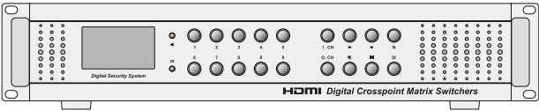

(B) DVI Front View:
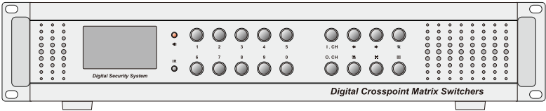
The front panel is received by the main keys, display, infrared, power four-part show, which was
Display screen for switching / setting status display, environmental temperature and humidity inside the chassis display, infrared receiver status display and other information.

1. 3.2 Rear panel diagram and description

Rear panel Illustration:
(A) 8 * 8 HDMI Rear panel Illustration:
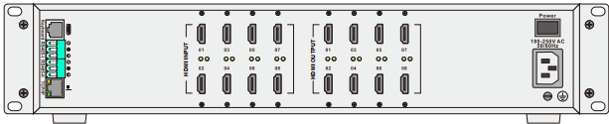

(B) 16 * 16 HDMI Rear panel Illustration:
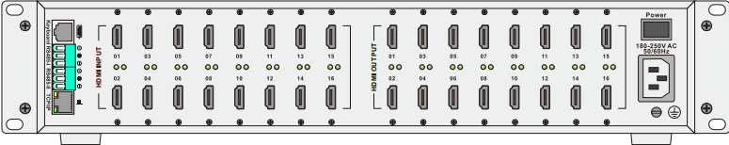

(C) 8 * 8 DVI Rear Panel:
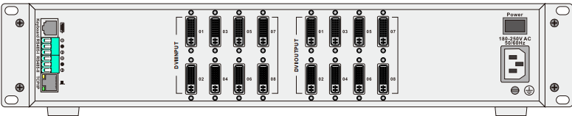

(D) 16 * 16 DVI Rear Panel:
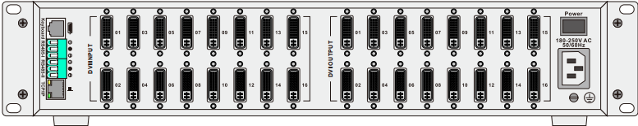

The rear panel consists of input and output channels, Keyboard port (includes RS485, RS232 control signal), TCP / IP (RJ45 port), RS485-I and RS485-II Six parts ports, power ports.

1.3 3. Installation instructions:
Metal standard 2 U (B type), 4 U (D type) chassis provides a standard mounting bracket, you can install this machine on a standard 19-inch rack, in order to be placed with other standard devices together.

1.3 4 Packing:

name | Items Figure | Quantity
HDMI Switcher |  | 1 set
DVI switch |  | 1 set
RS232 communication cable | 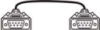 | 1
power cable |  | 1
Matrix testing and application CD |  | 1
User manuals and certificates |  | 1

1.4 connection diagram with peripherals and control equipment
HDMI when using the standard HDMI cable transmission, the maximum transmission distance of about 25 meters, can be very good to meet the needs of most home users. As for those luxury large space theater, you can use an extension cable or using repeaters, and even fiber optic HDMI cable to extend hundreds of meters, even hundreds of meters.
DVI is a digital signal transmission, the digital image data without undergoing any conversion, will be directly transferred to the display device, thereby reducing the digital → analog → digital cumbersome conversion process, saving time, so it's faster , the effective elimination of the smear phenomenon, and the use of DVI data transmission, the signal does not decay, the color is more pure, more realistic.Full HD monitor is recommended to use DVI, more than 1920x1200 resolution or the use of 3D, then you need to use dual-channel cable.
HDMI / DVI video and audio matrix switch hosts and ancillary equipment connection diagram is as follows:
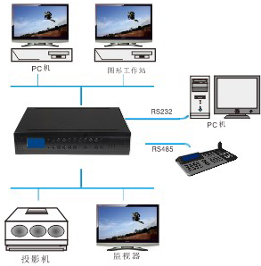

Part II: HDMI / DVI video and audio matrix switch system panel operation

2.1 Switch settings
Long press [  ] Switch to enter the menu settings. Press [] Key or [  ] Keys to move the cursor; after each option, enter the data basis having [ ] Key to confirm and to enter the next data input. Long press [ ] To return to the previous menu or exit the menu.
Program switch settings:
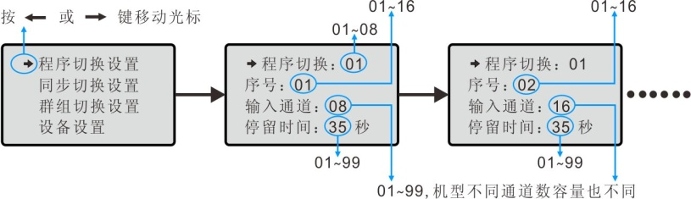
Salvos settings:
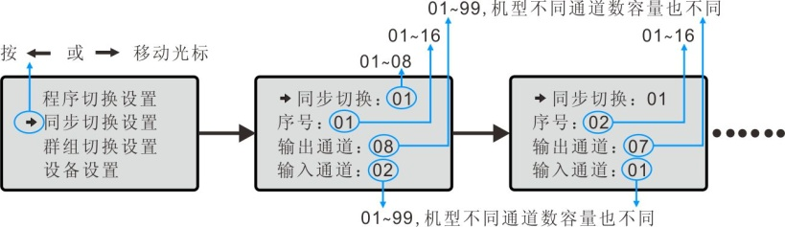
Groups switch settings:
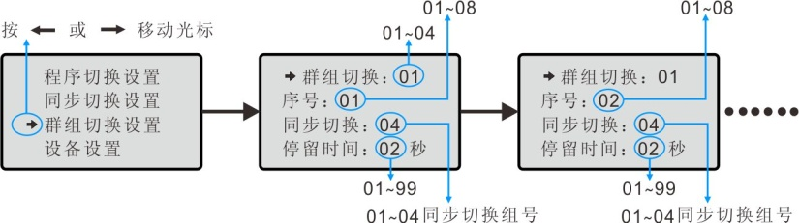

2.2 Device Settings
Device Settings entry contains three parts:
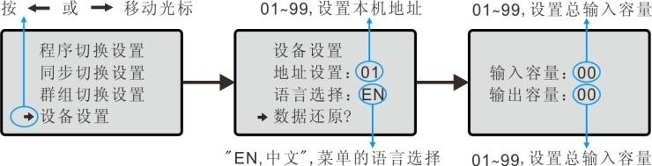
Address setting: 01-99, set the machine address, when you use the remote to control the unit must first enter the address of the machine in order to control the device.
Languages: English, Chinese. At present, only two languages ​​to choose from.
Data Restore: Select this option to enter the number of devices required to correct the input and output devices. This matrix is 40 (input) * 32 (output) device, then press the number of the input capacitance 40, press [ ] Button to confirm, and then press the number of the output capacity at 32, according to [ ]System to confirm and exit the menu.

2.3 Run and stop switch
2.3 .1 select input and output channels
For example: The 1st input channel switch the image to the 4th output channel
1. Press the number [4 ] Key, then press [O.CH] key; (select output channel)
2. Press the number [1 ] Key, then press [I.CH] key; (select input channels)
In this case, the 1st input image is displayed on the 4th output device.

2. 3.2 Forward and reverse switch
Reverse switch: Press[ ] Button, the image becomes operational mode switching back (decreasing).
Forward Switching: Press[ ] Button, the image becomes the way forward switching operation (increments);

2.3 3 Run, stop the program switch
For example: Run the 2nd program to switch.
Press the number [2 ] Key, press [ 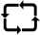 ] Key, you can run the program switching. Press a number key, then press I.CH] key to stop the program switching.

2.3 4 Run Salvo
For example: Run the 3rd Salvo.
Press the number [3 ] Key, press [  ] Key, you can run Salvo.

2.3 5 Run, stop community Salvo
For example: Run the 3rd Salvo.
Press the number [3 ] Key, press [  ] Key, you can run group switching. Press the number [0 ] Key, then press [ ] Key to stop the group switching.

Note: Only the menu is set corresponding program, synchronization, group switching parameters, the keys to perform the switching operation when active.

Part III： Infrared remote control for HDMI / DVI video and audio matrix switching operation

3.1 Infrared remote control feature
Rated voltage: DC3V
Operating voltage: 3V (2.4 ~ 3.5V)
Power: 100mW or less
Use Slim Battery: CR2025 * 1个
Carrier Frequency: 38KHz
Remote distance: 7 to 8 meters (horizontal and angle the remote distance is not the same)
Working environment: -50 ℃ ~ 40 ℃ (15 ~ 90% RH), 86 ~ 106Kpa
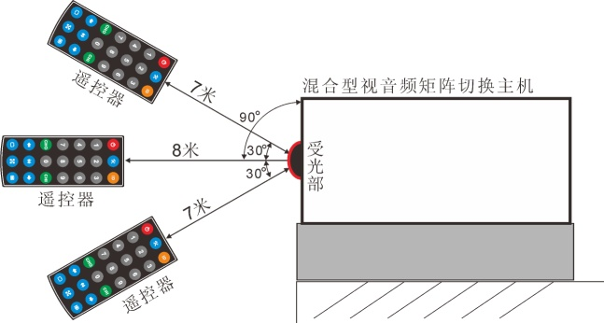

3.2 Key Description
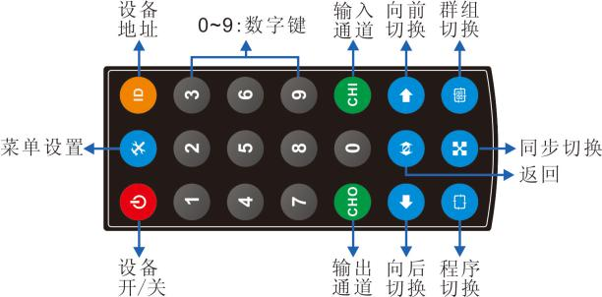

3 .2.1 open infrared remote control
Infrared remote control to open the package and remove the transparent film sandwich, before normal use. Close (within 7-8 meters) of the remote control to the controlled matrix switching device, enter the device address number (see note) on the remote control, then press " "Button, then the screen bottom right of the front panel of the matrix will display" "It indicates that the device has been affected by remote control.
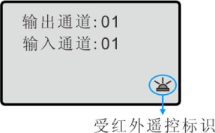
If no other user on any remote operation, 5 seconds after the device's screen. " "Disappears, the device will not be the remote control. Users need to re-enter the device address number and press" "Button to turn controlled.
NOTE: When matrix switching equipment factory, the default address is: 01, you can modify the device address number of01 to 99 users.
Modification method:
1. Close (within 7-8 meters) of the remote controlled SDI matrix switching equipment.
2. Enter the device address number 00 on the remote control, then press " "Button (or press" "Button), the display shows" . "
3. Press the remote control "  "To enter the menu settings.
4. press"  or  "Keys to move the cursor to the" Device Settings "item, press" "Button to confirm the input digital numbers: 01 to99.
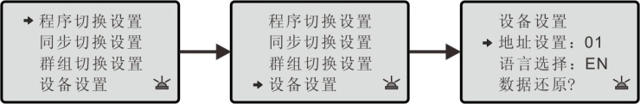
5. press"  "Return to the upper menu until you exit the menu settings.

3 .2.2 infrared remote control on / off control
By infrared remote control function is turned on, press "  "Button to close mixed video and audio matrix switching hosts. In this case, only the front panel power indicator is lit, the rest are closed again press" "Button, to open mixed video and audio matrix switching hosts, the display is powered display, the rest are starting to work.

3 .2.3 Switch settings
press" or "Keys to move the cursor; after each option in the input data according to the" "Button to confirm, to enter the next data input. Press" "Return to the previous menu.
Program switch settings:
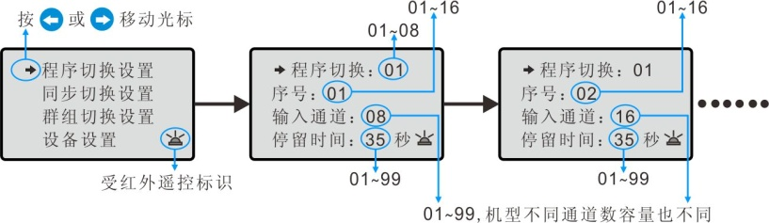
Salvos settings:
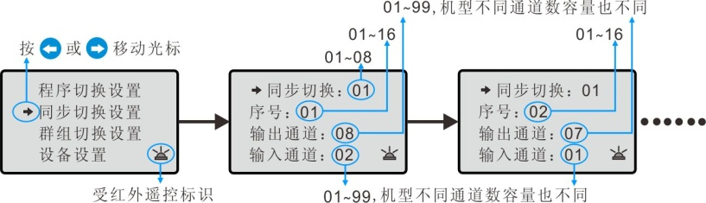
Groups switch settings:
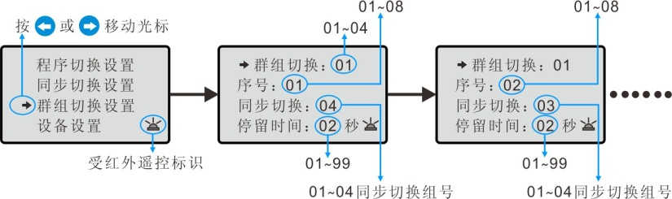

3 .2.4 run, stop switch
Only set up the appropriate procedures, synchronization, group switching, when the operation is switched, the corresponding output device displays the image will change, and the data input panel display / output channel will change with the change switch .
Select the input and output channels switch images:
For example: The 1st input channel switch the image to the 4th output channel
1. Press the number [4 ] Key, then press [ ] Key; (select output channel)
2. Press the number [1 ] Key, then press [  ] Key; (select input channels)
In this case, the 1st input image is displayed on the 4th output device.
Forward, backward switch images:
Press " "Button, the image becomes the way forward switching operation (increments);
Press " "Button, the image becomes the way back switching operation (descending).
Run the program switching:
For example: Run the 2nd program to switch.
Press the number [2 ] Key, then press " "Button, you can switch to run this program.
Stop program switching:
Press the number keys, then press [ ] Key, you can stop the program switching.
Run Salvo:
For example: Run the 3rd Salvo.
Press the number [3 ] Key, then press " "Button, you can run this salvo.
Run group switching:
For example: Run the 3rd Salvo.
Press the number [3 ] Key, then press "  "Button, you can run this group switching.
Stop group switching:
Press the number [0 ] Key, then press " "Button, you can switch to stop the group.

Part IV：Keyboard control for HDMI / DVI video and audio matrix switching operation

4.1 Keypad Instruction
When mixed video and audio matrix switching equipment factory, according to user requirements might be equipped with the appropriate external keyboard. Different keyboard, the corresponding mode of operation and function will be different. When the operation, press the keyboard configuration instructions.
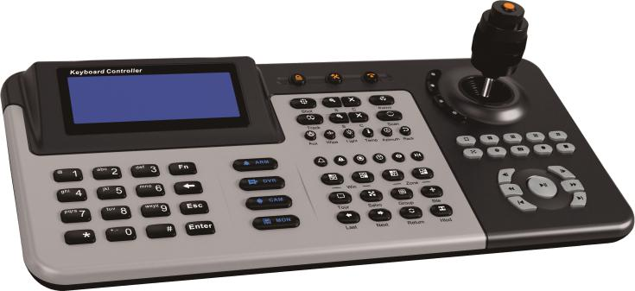

4.2 Main operations, external keyboard for mixed video and audio matrix switching hosts

4 .2.1 keyboard login and logout operations
Password is a secure process, users must have a user password can access the system. After the keyboard is properly connected with the host matrix, after the host matrix power, keyboard and display "Password" prompt enter the operator password. Enter the password (original password 000000) and press [ ] Key login.

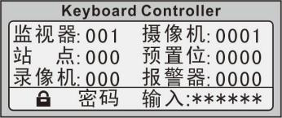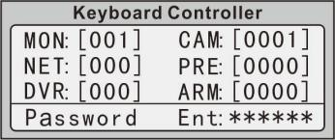

If the password is incorrect, the data display area prompted to re-enter your password; if the password is correct, the display will show the monitor host's system time or "Keyboard".

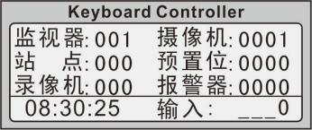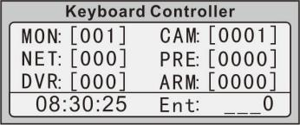
Keyboard Logout: After keyboard operation, in order to prevent the unlawful operation, press [ ] Key keyboard into the operating protection status (logout the user), a keyboard screen status display shows "Password."
Note: The user should change the original password to prevent unauthorized personnel to operate the keyboard.

4 .2.2 run, stop switch
Note: For keyboard can control the switching matrix host, you must first set up the keyboard control protocol (AUTO), the communication rate (9600) and the keyboard number (the default is 00). Specific settings, please refer to keyboard instructions.
External keyboard can digital matrix corresponding switching operation, as follows:
I. Select the input and output channels to switch images.
For example: Choose the 3rd image is displayed on the 1st monitor.
1. Press [1] key, then press [MON] key;
2. Press the number [3] key, then press [CAM] key. At this time the 1st monitor displays images on the 3rd screen.
II. Forward, backward switch images.
press【 】Button, the image switches to the way forward switching operation (incremented);
press【 】Key, the image mode is switched to the backward switching operation (decreasing number).
III. Run, stop the program switching.
For example: On the 3rd monitor runs on the 2nd program to switch:
1. Enter the digital [3], press [MON] key to confirm the monitor;
2. Enter a number [2], press [ ] Key to run the program switching.
press【  ] Key or enter the camera number, then press [CAM] key to stop the handover.

IV. Salvo runs.
1. Press the numeric keys, enter the synchronous switching queue number (1 to 8);
2. Press [ ] Key to confirm the synchronous handover.
When the number of monitors synchronous switching queue exceeds the maximum number of monitors, the extra camera image will not be displayed.
Five. Run, stop the group to switch.
1. Press the numeric keys, enter the group switching queue number (1 to 4);
2. Press [ ] Key to confirm the implementation of group switching.
Press [ ] Key or press the number [0] key, then press [ ] Key, you can stop running group switching.

Part V. Troubleshooting and Maintenance

1. Signal interferences: Check the signal cable and plug connection is good, the cable meets the regulatory requirements, the system ground is good, the AC ground system between the devices are the same. The equipment used must be connected to a power supply protected and guaranteed power protection to the same input and output devices for the same protectorate. For the computer user communication control must ensure that the use of a computer and the device are connected to a power protected, and the same protective ground.
2. (Such as when the projector ghosting) to the device connected to the external device image ghosting: This equipment is generally not a problem, it may be the projector is not properly adjusted, to deal with the appropriate buttons to adjust the projector; may be wire quality standards, response corresponding buttons to adjust the projector or replace the wire; the wire may be too long to cause signal attenuation, should increase long-term drive; may be strong and 220V AC electric hybrid installation.
3. The serial port can not control equipment: Check the control software communication port is set corresponding to the connected serial devices; communication port Check your computer is good.
4. Keyboard can not control this device: Check the RS485 communication cable is connected, the interface is the corresponding; check if the keyboard works properly; check the keyboard settings if the baud rate of the communication device port control protocol match.
5. The device is switched without a corresponding image output:
(1) Check whether the corresponding signal input terminal. (Available oscilloscope or multimeter test) if there is no signal input, there may be input cable connector loose or broken, replace the cable can be; DVI cable HDMI cable is too long or too long resulting in no signal input, can be replaced short cable.
(2) Check whether the corresponding output signal. (Available oscilloscope or multimeter test) if there is no signal output, there may be output cable connector loose or broken, replace the cable can be; DVI cable HDMI cable is too long or too long resulting in no signal output can be replaced short cable.
(3) Check the output port numbers are consistent with the controlled port number. Does not belong to the above three cases, the possible internal failure of the device, repairs to the professionals.
6. Stubbs, when inserting video interface, feel there is a clear static: Check that the external device power to end well grounded, grounding the correct method, or easy to damage the host.
7. POWER lamp is not lit, and the keyboard no response: Possible power supply is not normal.
8. This equipment is prohibited within the debris fall into, if debris should immediately cut off the power to stop working, clean up and then continue to work; do not use near high heat; to ensure air circulation, do not let the heat build-up within the device; do not place the device on excessive moisture or dust.

Security matters:
Installation should be made ​​by qualified service personnel, please comply with the relevant safety regulations when operating.
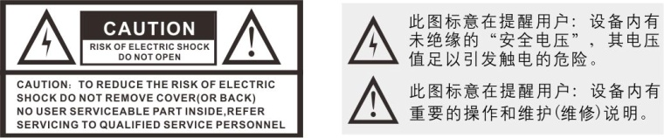
Before installing and using the equipment shall comply with all warnings and instructions on the equipment, and comply with all instructions and instructions for use.
1) Do not use the device in the power supply voltage is too high and too low occasions.
2) This equipment is indoor equipment, in order to prevent short-circuiting or shock hazard, do not place the device in a wet environment.
3) Do not touch the power switch with wet hands and equipment to prevent electric shock.
4) When installing the device during the wiring or change the line should disconnect the power supply to prevent electrical shock.
5) Do not spill liquid on the device, to prevent causing an internal short circuit or fire equipment.
6) To prevent electric shock and fire, do not place the device on flammable and explosive places.
7) before wiping device, disconnect the power, do not use liquid or spray strong cleaning agents, please wipe with a dry cloth.
8) Do not put the device on an unstable seat and child care will be violent vibration, in order to prevent personal injury when the device is dropped, damaged equipment.
9) Handle with care facilities avoid strong impact, vibration, etc., to prevent damage to the device.
10) To ensure proper cooling devices should avoid poorly ventilated areas.
11) In order to avoid damage to the equipment, do not open the case on their own, we must be entrusted to qualified service personnel in the designated maintenance units for maintenance.
12) Avoid too cold, mutual moving between places of overheating the device, in order to avoid condensation inside the device, affecting the life of the equipment.

【Packing List】:
name | Items Figure | Quantity
1. Hybrid video and audio matrix switching hosts | 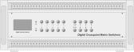 | 1
2. Power (or power cord) | 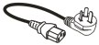 | 1
3. Use manual and certification |  | 1
4. Remote Control | 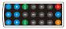 | 1

